I Remember when: Life in 1930s St. Johns County
The History Workshop
St. Johns County, Florida
2010

Student Activity: How did people living in rural St. Johns County use natural resources in their everyday lives.

Time Needed: three hours

Objective(s): Students will understand and describe life in 1930s north Florida.
Students will write a story based on a person from the read aloud or oral history stories.
Students will support their ideas with evidence from the lesson content.
Students will analyze primary sources and gather information from the text.
Students will integrate information from multiple sources and write about the subject.

Supplies for this Activity:
Teacher’s Guide and Answers
Video: Up From the Roots: Remembering Rural St. Johns County
Up From the Roots Worksheet
Walk Through the Woods Photograph Handout
Walk Through the Woods Photograph Study Worksheet
Watermelon Picnic Photograph Handout
Watermelon Picnic Photograph Analysis Worksheet
Oral History Transcript “Visiting” Handout
Oral History Worksheet
Hugie’s Education Short Story Handout (PDF)
Hugie’s Education Worksheet

Activity One: Building prior knowledge—Remembering Rural Florida

Instruction:
Students will watch the 8-minute video or clips 0:00-2:20 and 4:00-10:15 from the video Up From the Roots: Remembering Rural St. Johns County.
As a teacher-guided classroom activity students will:
- Identify six to eight facts, distinguishing between fact and opinion;
- Connect the information to themselves or to other historical events;
- Think of questions they would ask the people who lived in St. Johns County before they were born.

The teacher or each student will record facts and interview questions on the board and refer to them throughout the lesson.

Discussion:
The teacher will lead a classroom discussion about the how the life in St. Johns County today is different from the lives of people interviewed in the video. The teacher should explore the idea of whether it is better or just different.
- Are the interviewees are just remembering the good parts?
- What advantages did the people who were interviewed have?
- What kinds of things did they not have access to? (medical advances; better education; etc.)
- Imagine no TV, no electricity, no running water; no paved roads

Assessment:
Using the class answers from the teacher guided discussion and information from the video, students will work individually or in groups to complete the Up From the Roots.

Activity Two: A Picture is Worth a 1,000 Words

Instruction:
The teacher will lead a discussion about photographs as primary sources. Supporting information is available in the Teacher Guide
- What is a primary source?
- What information can we learn from a photograph?
- Should we believe everything we see in a picture?
- Are some photos more reliable than others?

Activity and Discussion:
The teacher will project and/or provide students with a copy of the Walk Through the Woods Photograph Handout.

As a teacher-led discussion, the class will look at the image and make a list of everything they can see in the picture. As a teacher-led classroom activity or working in groups students will complete the Walk Through the Woods Photograph Study Worksheet.

Assessment:
Using the photography analysis skills learned during the activity, students will work individually or in groups to complete Watermelon Picnic Photograph Analysis Worksheet.

Activity Three: I Remember When…

Instruction:
The teacher will lead a discussion about primary sources with particular emphasis on first-hand accounts or oral interviews.
- What is a first person account?
- What kind of information can we learn during an interview?
- Should we believe everything someone remembers?
- Where else are interviews used to present information?

Activity A:
The teacher will project and/or read aloud the Oral History Transcript “Visiting” Handout. As a teacher-led activity students will:
- Identify three facts from the interview
- List three ways the life of the interviewee is different from their own
- List of questions the class would ask an oral history participant

The teacher or students will record the answers on the board.

Activity B:
The class will conduct oral history interviews. The teacher will distribute two cards to each student. Students will write an interview question on each card. The teacher will place all of the cards in a container.

Students will divide into two-person teams. Each student will select two interview question cards from the container and use the questions to interview their partner.

Each student will write a summary of the interview of their partner.

Discussion:
The teacher will lead a discussion about the results of the interview session. Students will explore the results of their interviews.
- What did you learn from interviewing your classmates?
- What could future researchers learn about your life from reading your summary?

Assessment:
Using the skills learned during the classroom activity, students will work individually or in groups complete the Oral History Worksheet.

Activity Four: When I was a Kid

Instruction:
The teacher and/or the class will read out loud the short story presented in the Hugie’s Education Short Story Handout. The teacher will explain that this story is written by Hugie’s son. It is based on oral interviews between father and son.

Activity:
The teacher will lead a classroom discussion of the story.
- What was life like in 1930s north Florida?
- What would it be like to grow up like Hugie?
- Do you know someone who grew up on a farm?

As a classroom activity, students will:
- List three things Hugie does that children do today.
- List three things Hugie does that most children so not do today

Discussion:
The teacher will lead a classroom discussion about the story and its value as a source for information about life in rural Florida during the early twentieth century. The teacher should focus on the way the author has used an oral interview to create a more intimate picture of daily life.

Assessment:
Students will work individually or in groups to complete the Hugie’s Education Worksheet

“I Remember When…” Lesson Plan
Worksheets and Documents

Up From the Roots Worksheet

The video Up from the Roots helped us learn about life along William Bartram Scenic and Historic Highway in the 1930, 1940s, and 1950s through the memories of its older residents. Use information from the video and the class discussion to answer the following questions.

- A historian visited the people in the video and asked them questions about their life. This is called an oral interview. What is special about their stories? How is it different from reading a history book?

- Where can researchers find recordings and records of oral interviews?

- All of the people in the video talked about how times have changed. List three ways life in St. Johns County has changed since the people interviewed were children.
1.
2.
3.
- All of the people in the video talked about their childhood. List three things the people interviewed remember about their childhood.
1.
2.
3.

- In the 1930s and 1940s there were not a lot of jobs in St. Johns County. All of the people in the video talked about making a living off the land. Name three ways people in St. Johns County used to make a living.

1.
2.
3.

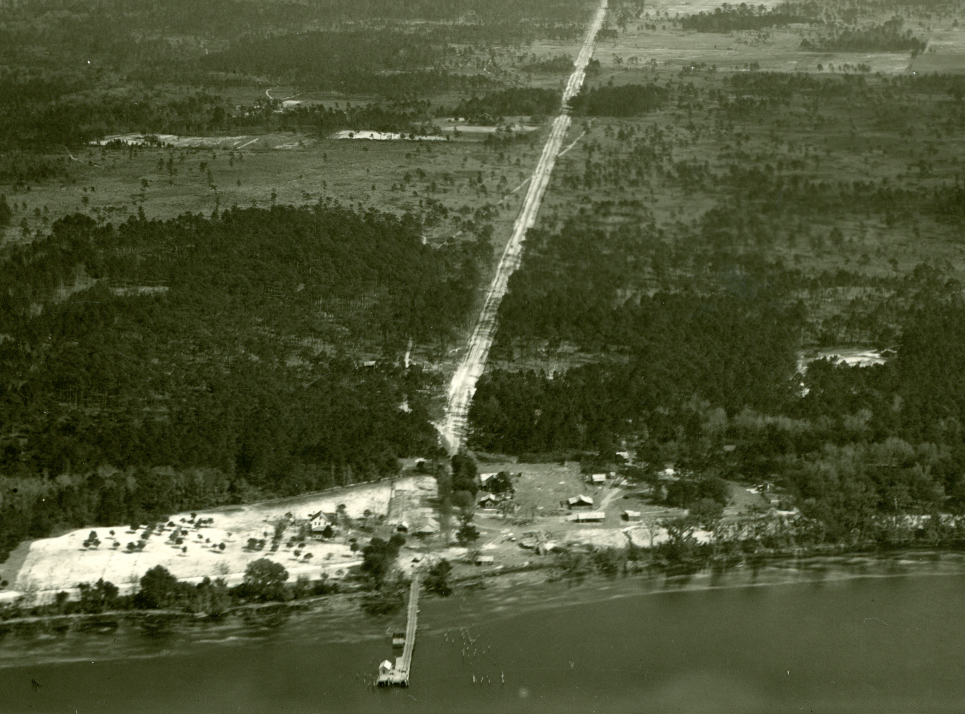
Picolata in 1928
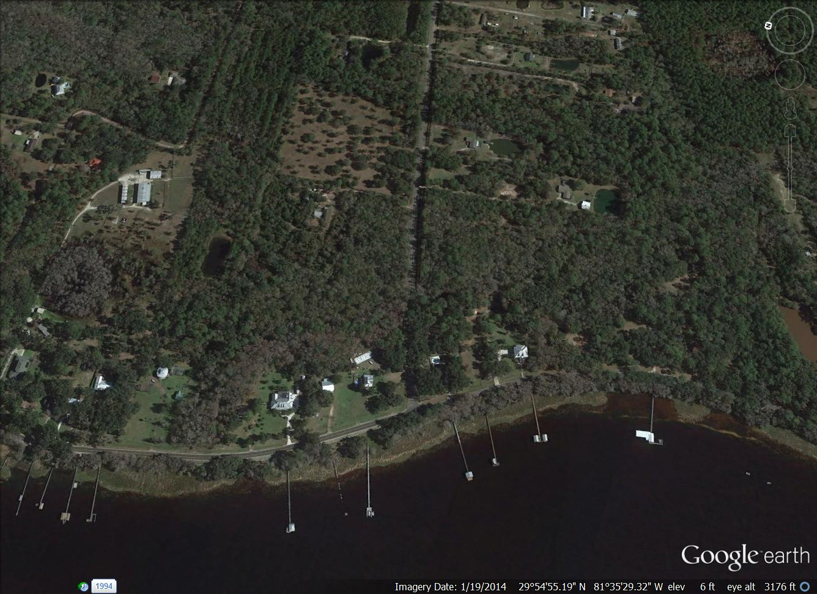
Picolata in 2010

- Look at the two photographs of Picolata. List three things that are the same. List three things that are different. Can you find State Road 13 in the 1928 photograph?

- When was State Road 13, now William Bartram Scenic and Historic Highway paved?

- When did electricity arrive along the highway?

- The people in the video talked a lot about the St. Johns River. Today it is an American Heritage River. List three resources they collected from the river.

1.
2.
3.

- If you could interview one of the people in the video, what question would you ask and why?

A Walk Through the Woods Photograph Handout

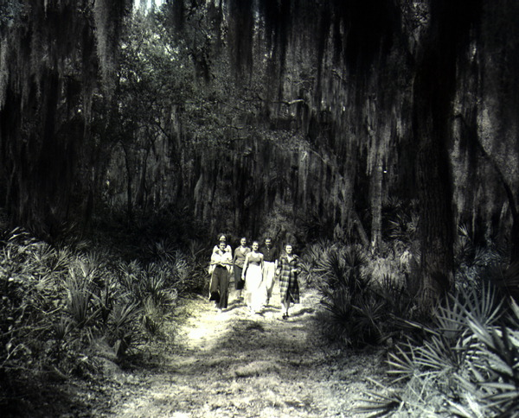

Walk in Through the Woods Photograph Study Worksheet

Use the Walk Through the Woods Photograph Handout and results of the photograph analysis to answer the following questions as a class.

1. Describe the main activity in the photograph.

2. Where does this scene take place? Does it look familiar?

3. Who do you think took the photograph?

4. What is the mood of the scene (happy, sad, scary, exciting, boring)?

Use this chart to determine the following:

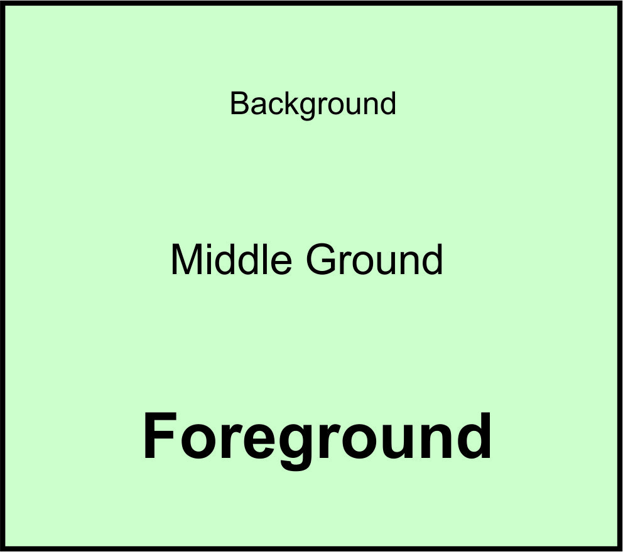

5. What is in the foreground of the photograph?

6. What is in the middle ground of the photograph?

7. What is in the background of the photograph?

8. What is the main focus of the photograph?

9. Researchers look for clues in old photos to learn about the past. What do the girls' clothes tell you?
10. What do you think the group is doing or is about to do?

11. People take photographs to remember important events, to brag to their friends, or because they are having fun. Why do you think the photographer took this picture?

12. Write a caption for the photo.

Watermelon Picnic Photograph Handout

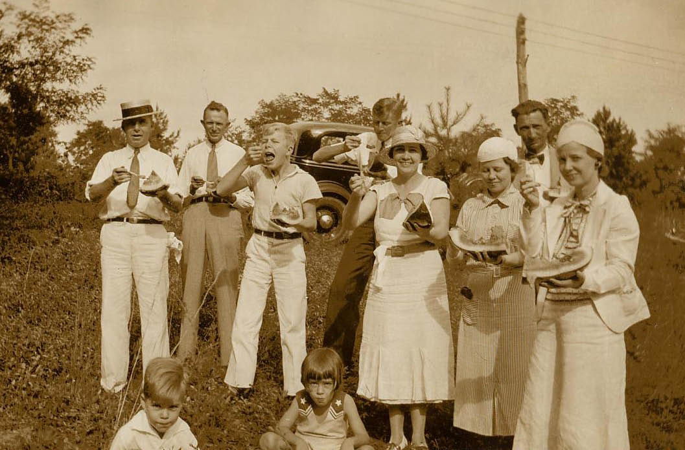

Watermelon Picnic Photograph Analysis Worksheet

This photograph was taken in St. Johns County around 1930. Study the photograph carefully to answer the following questions.

1. Study the photograph for one minute to form an overall feeling about the photograph. List three (3) attributes of the photograph you notice right away.

1.____________________________________
2. ___________________________________
3.____________________________________

2. Study the photograph more carefully and record the information about the people, objects, and activities you can see in the chart below.

Photograph Analysis Chart
People | Objects | Activities

3. Divide the photograph into four equal parts by drawing horizontal and vertical lines through the middle of the picture. Make a list of the objects, and people you see in each square. Compare this list to the list you made in Question 2. Did you miss anything?

Top Left | Top Right | Bottom Left | Bottom Right

Use the information you have collected from your photograph analysis to answer the following questions:

4. List three (3) things that tell you this is an old photograph.

1.____________________________________

2. ___________________________________

3.____________________________________

5. What do you think is the subject of the photograph? Where do you think the event takes place? Support your answer with examples from the photograph.

6. List three (3) questions this photograph raises in your mind.

1.____________________________________

2. ___________________________________

3.____________________________________

Use best judgment to determine their logic.

7. Where or how could you find answers to those questions?

8. Why do you think the photographer took this picture?

9. List three (3) words you think describes how people in this photograph feel.

1.____________________________________

2. ___________________________________

3.____________________________________

4.____________________________________

10. Does your family go on picnics? Where is your favorite place to go? What is your favorite picnic food?

Oral History Transcript “Visiting” Handout

BEACH: We had a lot of neighbors, and maybe once or twice a month, we’d have neighbors to come over and eat with us. We had a lot of neighbors out here at that time. There was a lot of houses out here. We didn’t have television and had an old radio. It was a battery, and you didn’t want to use it except for special occasions. We visited a lot, and we’d sit on the porch at night and talk with no lights.

INTERVIEWER: Let me ask you about that. What do you mean “we visited?” Tell people, because they don’t know that phrase nowadays. Young people don’t know that phrase.

BEACH: Well, we’d just talk about the times, what was goin’ on, what the neighbors were doin’, whatcha plantin’, and these type of things.

INTERVIEWER: You’d go over to somebody’s house and sit down and talk.

BEACH: Yeah, everybody’d visit one another. That was our entertainment. As a family, we’d visit everybody in the neighborhood. Everybody’d come around just whenever. You didn’t have a telephone, so you didn’t call anybody. You just showed up at the house. If they were eatin’, you were welcome to come in and eat, too.

Oral History Worksheet
Read the following oral history interview and answer the questions below.
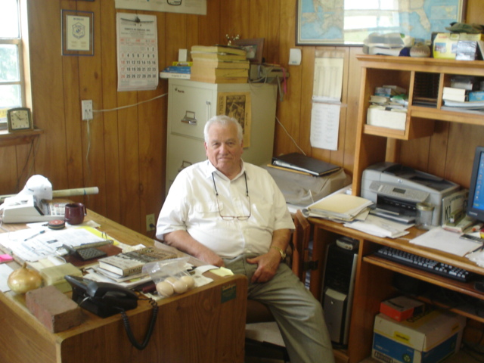
From: Memoirs of Thomas Beach, August 14, 2008
To be brought up right after the Depression, we ate very good. We had our own livestock. We had beef; we had pork; we had chickens; and we had a big garden. We were mostly self-sufficient except for sugar, salt, flour, and things of this sort. But we’d grow corn, and we’d make our own grits. We’d grind it up with a grinder that we had. My dad was a big rice eater, so we had to buy rice in town. We’d go to town on Saturdays. We’d gather the eggs up, and we’d carry two big baskets of eggs to town and trade it for groceries. Usually that’d buy all the staples that we needed from town, and we’d have a little money left over, and we’d go by the feed store and maybe buy a 100-pound bag of chicken mash for layin’ chickens where they’d lay more eggs. Mamma’d always go in and pick out a pattern from the bag the layin’ mash came in to make shirts or dresses or whatever.

- Mr. Beach talks about raising cows and chickens and growing a garden. Do you think these are happy memories? What is the most important message Mr. Beach wants to share with the interviewer?

- Bartering means to trade something you have for something you need without using money. Give an example of bartering from the interview.

- List three food items the Beach family could not produce on their farm.

- Often people who lived through the Depression were careful to reuse useful things. Give an example of how the Beach family reused items.

- What food does Mr. Beach remember his father liked to eat?
- Cat fish
- Eggs
- Rice
- Peanut Butter

- What did Mr. Beach grind to make grits?
- Rice
- Corn
- Wheat
- Peanuts

- What did the Beach family not produce on their farm?
- Corn
- Sugar Cane
- Chickens
- Pigs
8. Are there other questions you would like to ask Mr. Beach? Think about the kinds of things he did not mention and every-day life. Write out two questions.

Hugie’s Education Story Handout
An excerpt from the “Hugie’s Education” in Pioneer Family: Life on Florida’s Twentieth Century Frontier, p.13-16
By Michel Oesterreicher

ON A DECEMBER morning in 1905, Hugie nestled into the mattress and pulled the quilt over his cold ears. Only minutes had passed when, outside the low bedroom door, he heard the soft footsteps of his mother moving toward the kitchen. Raising himself quickly, he jerked a large share of the quilt with him, exposing his brother George to the cold air of the room. "What you doing?" George moaned. "Time to get up; we got school," Hugie said, reaching for the new canvas britches his mother had made him on her treadle sewing machine. "Let's get going."

Hurriedly he pushed through the back door of the cabin, moving through the cold dark morning toward the warmth of the kitchen. Entering the kitchen, he found his mother standing over the stove browning sausage links in the iron frying pan. Hugie stepped beside it, slowly turning to warm his entire body. Shortly after breakfast, Hugie and George ran down Old King's Road toward the little school, which sat in a cleared place beneath a grove of trees a couple of miles from the their cabin. The school was a one-room wooden structure that provided education through the eighth grade. When Hugie and George arrived at the grove, smoke was billowing from the chimney of the schoolhouse. Hugie liked school. He liked being with children other than his brothers and sisters. But most of all, he liked learning. In this small classroom, he was exposed to math and reading, and his sharp young mind absorbed everything that went on there.

Later that day after Hugie and George had returned from school, the family gathered around the supper table and listened to Tom tell stories. Tom loved telling tales, such as family histories and Civil War stories. After a few family stories on that December evening, though, Tom started talking business. "We got a big order for palms. Going to take all of us to fill it," he said, looking at his boys. He caught Hugie's eye. "Me too?" Hugie asked, excited at the thought of being included with his older brothers. "Yeah," Tom said, "you too." Hugie grinned, not understanding that becoming part of the family workforce meant that his formal education had for the most part come to an end. To him, at that time, helping his father and older brothers cut palms meant only that he was gaining their acceptance as an equal.

Cutting palms in the late winter and early spring months added hundreds, sometimes thousands, of dollars a year to the family's income. Each winter, orders came from the nation's churches for fresh-cut palm buds for the celebration of Palm Sunday, one week before Easter Sunday. The year Hugie was seven years old, he spent the Christmas holidays digging sweet potatoes and anticipating his palm-cutting excursions into the woods with his father and brothers.

And when January arrived, it was palm season. The first morning, Hugie was full of excitement as he climbed with his brothers into his father's cart and began the trek down Old King's Road to Cabbage Swamp, where there were thousands of cabbage palms. As they neared the grove sheltering the schoolhouse, Hugie sat up in the cart listening, intently watching for some of his friends or Mrs. Browning. When they passed the schoolhouse, the young boy peered through the darkness of early morning at the little whitewashed building. No sounds came from the building, no light glowed in the windows, and no smoke streamed from the chimney. "No one here yet," he thought, sinking back into a corner of the wagon, "too early."

The cart creaked beneath the shadows of the cabbage palms and live oaks and past knotted masses of loblollies. When Tom halted the horse, the boys jumped out and looked around at the swamp in the rosy morning light. They gathered their tools as Tom issued directions. Hugie's job was to gather into bundles the palms cut by his older brothers. Each of the young men worked rapidly, while Hugie trailed behind them, diligently picking up the palm buds, straightening them, and putting them into piles. He didn't want to give his father and older brothers any occasion to tease him for not doing the job right or for lagging behind. The sun was getting low and the shadows long in Cabbage Swamp before Tom and his sons began to gather the bunches of palms into their arms and carry them to the cart.

The sun was sinking behind the trees and dusk was settling over the woods when the cart turned onto the familiar road home. Hugie, lying exhausted on the pile of palms, turned his head and peered over the side of the cart into the shadows of the grove surrounding the schoolhouse. He looked and listened. There were no sounds of laughing children from the schoolyard, no light gleaming from the windows, and no smoke streaming from the chimney. "Too late," he thought, "they’ve all gone home." Hugie didn't go to school that spring of 1906. In fact, after that he only attended school in the fall sessions. Each year, after Christmas, during the late winter and early spring months, he worked beside his father and brothers deep in the woods and swamps of northeast Florida.

Hugie’s Education Worksheet

- Hugie’s story was written by his son and is based on an oral interview with his father. Is this a primary source or a secondary source? How do you know?

- Although the author made a story out of the interview with his father, what kind of information about life in rural Florida can you find in the story? List three (3) things you learned.

- Are you surprised to learn children often went to work before they were 16? Why do you think it was necessary? Can you think of businesses where children might work with their parents?

- When Tom told Hugie he could pick palms he was excited. Do you think his feelings changed? Why?

- Think about how Hugie’s life is different or similar to your life. Fill in the chart

How My Life is Like Hugie’s | How My Life is Different from Hugie’s

6. Answer the multiple-choice questions based on the story.
- Where did Hugie’s go to school?
- In a trailer
- A one-room building with a chimney
- In a large brick building
- He was taught at home

- Why did Hugie want to work with his brothers and father?
- He wanted pocket money
- He wanted to buy a toy
- To be like his brothers
- To help his family

- What did Hugie do at Christmas when he was seven years old?
- Drank cocoa by the fire
- Cut palms
- Played with his toys
- Dug sweet potatoes

- Which grades were taught at Hugie’s school?
- Kindergarten
- First grade
- Kindergarten -5th grade
- Kindergarten - 8th grade

Teacher’s Notes on the Activity: See Worksheets and documents

Challenges:

Bibliography of [Subject]: See Worksheets and documents.

