“Al andar se hace camino” – “The road is made by walking”
Antonio Machado, Proverbios y cantares XIX,
Translated by Bettie Jean Craige

Note to Readers: the definitions of mission, vision, values and strategic objectives will not appear in the final draft plan

Mission (our reason for being in business)
OHA connects diverse individuals and organizations that collect, preserve, interpret, and share the voices of people with first-hand experience of the past, recorded in interview form.

Vision (a picture of where we will be at the end of this planning period)
The Oral History Association is a dynamic crossroads for the many paths to and from oral history.

Values (the unique characteristics embedded in our work) (rules of the road)
- Democracy – As practitioners, we invite, collect, record, interpret, preserve and share first-person, first-hand accounts that otherwise might not be included in the historical record.
- Inclusivity – As an organization, we foster the democratic nature of oral history by ensuring that our membership, research and outreach encompass diverse practices, constituencies and perspectives.
- Engagement – As educators and learners, we advocate for and adhere to high standards in the conduct, curation, dissemination, and interpretation of oral history interviews.

OHA Theory of Change (a snapshot of the dynamics that are in play in this strategic plan):
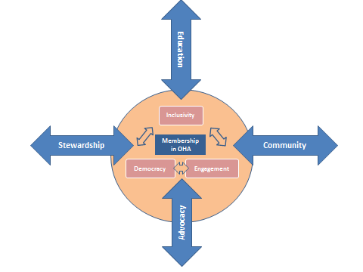

People who come to the gathering place created by OHA may come and go through any number of pathways. The four pathways shown here are:
- Education –teaching, learning and research by practitioners in a variety of formal and informal settings
- Community practice –projects, organizations, individuals, cultures and creative acts that are inspired and informed by oral history.
- Advocacy – efforts to include and amplify diverse voices and experiences to inform public and private reflection and action.
- Stewardship -- practitioners involved with the archiving, curation, preservation and dissemination of oral history.

Strategic Objectives (How we will advance our mission and achieve our vision.)
Note to Readers: To assist in your review, we have included a date for completion for each goal. The date will not appear in the final plan.
Operations (roads and bridges) -- [By 12/31/2014] OHA will have a consolidated infrastructure sufficient to support the goals of this strategic plan, including: home office staff; business planning and operations; executive leadership ; and capacities for communications, outreach, convening and publications.
Annual Meeting (the traffic circle) -- [by 12/31/2017] OHA will position the annual meeting as a gathering place where diverse constituencies can gain knowledge, practical experience and tangible benefits that extend beyond the conference itself.
Membership (the way we walk) -- [By 12/31/17], Membership in OHA will be a highly valued link to uniquely available member services, discounts for services and events offered by OHA and its partners, and information about oral history.
Technology (multi-use, safe, innovative, user-friendly access) -- [By 12/31/2017] OHA will be a portal to exemplary digital technology and comprehensive and productive connections among people, organizations and institutions who are interested in oral history.
Outreach and Partnerships (getting on the map) -- [By 12/31/2017] OHA will have a wide range of partnerships and associations that extend and support its mission, values and financial bottom line.
Finance (how we will pay for it all) -- [By 12/31/2017] OHA will deploy a strategic approach to revenue generation (grants, sustainers and other forms of member contributions, planned giving, publications, sponsorships, etc.).

